# **Product Dissection on Amazon E commerce business platform**

### **Contribution - *Individual***

### **Team Member 1 - *Sudipta Ghosh***

# **Step 1: Choose a Leading Platform "Amazon"**

**For the purpose of this case study, I choose "Amazon" as the leading e-commerce platform to focus on schema design. Amazon is one of the largest and most well-known e-commerce platforms globally, offering a wide range of products, services, and features to users.**

# **Step 2 Research**

**Company Name:** Amazon.com, Inc.

**Founded:** July 5, 1994

**Founder:** Jeff Bezos

**Headquarters:** Seattle, Washington, United States

**Industry:** E-commerce, Cloud Computing, Artificial Intelligence, Digital Streaming, Consumer Electronics, Retail

**Website:** Amazon.com

**Overview:**

Amazon is a multinational technology and e-commerce company known for its diverse range of services and products. What started as an online bookstore has since grown into a global conglomerate that revolutionized online shopping, cloud computing, and digital services. Here's an overview of its key business segments:

* **E-Commerce:** Amazon's primary business is its online marketplace, where customers can find and purchase a wide range of products, from books and electronics to apparel and home goods. The company's user-friendly interface, efficient delivery, and customer-centric approach have contributed to its immense success in the e-commerce sector.
* **Amazon Web Services (AWS):** AWS is Amazon's cloud computing platform, offering a suite of services such as storage, computing power, database management, analytics, and more. AWS has become a dominant player in the cloud industry, providing infrastructure for businesses of all sizes.
* **Amazon Prime:** Amazon Prime is a subscription service that offers benefits such as fast and free shipping, access to streaming services like Prime Video and Prime Music, exclusive deals, and more. It has played a significant role in building customer loyalty and engagement.
* **Digital Content and Services**: Amazon provides digital content services, including e-books through Kindle, digital music through Amazon Music, and video streaming through Amazon Prime Video. It produces original content and offers subscriptions for additional channels.
* **Consumer Electronics:** Amazon designs and manufactures its consumer electronics, including the Amazon Echo line of smart speakers powered by the voice-controlled virtual assistant Alexa. These devices integrate with various Amazon services and third-party applications.
* **Third-Party Marketplace:** Amazon's marketplace allows third-party sellers to list their products on the platform, increasing product variety and availability. This has empowered small businesses and entrepreneurs to reach a global audience.
* **AI and Technology:** Amazon invests heavily in artificial intelligence (AI) and technology innovation. Its AI-powered recommendation system, supply chain optimization, and automated warehouses contribute to its operational efficiency.

# **Step 3: Product Dissection by the platform**

### **Product Dissection:**

### ***Product Listings and Descriptions:***

Amazon provides detailed listings for a vast range of products. Each listing includes product images, descriptions, specifications, and customer reviews, helping users make informed purchasing decisions**.**

### 

### 

### ***Personalized Shopping Experience:***Amazon's recommendation system suggests products based on a user's browsing and purchase history. This enhances the shopping experience and helps users discover relevant items**.**

### ***Variety and Availability:***Amazon offers an extensive variety of products, from electronics to books to groceries. This extensive range ensures that users can find and purchase items they need.

### ***Efficient Search and Filters:***

The platform's search functionality, combined with filtering options, enables users to quickly find specific products based on keywords, categories, brands, and other criteria.

### ***Third-Party Sellers****:*

Amazon's marketplace allows third-party sellers to list and sell products. This increases the variety of products available and provides opportunities for small businesses to reach a wider audience.

**Secure Transactions:** Amazon ensures secure transactions by providing various payment options, including credit/debit cards and secure payment gateways.

### **Real-World Problems:**

### ***Information Overload:***

With countless products available, customers face the challenge of finding suitable products. Amazon's detailed product descriptions, images, and reviews address this issue.

### ***Choice Paralysis:***

Having too many choices can lead to decision paralysis. Amazon's recommendation system suggests products, making the decision process easier**.**

### ***Convenience:***

Traditional shopping often requires visiting multiple stores. Amazon offers the convenience of shopping from home, with doorstep delivery.

### ***Access to Remote Sellers:***

Users can purchase items from sellers in different parts of the world, expanding their options and access to unique products.

### ***Fraud and Security:***

Online transactions can be risky. Amazon's secure payment system and robust customer support help mitigate fraud and security concerns.

### ***Global Accessibility:***

Amazon's platform allows customers from different countries to access and purchase products, breaking down geographical barriers.

### ***Empowering Small Businesses:***

Amazon's marketplace enables small sellers to compete on a larger scale, giving them access to a massive customer base.

# **Step 4: Case Study on the real world problems and approach to solving them**

### **Problem 1: *Information Overload and Choice Paralysis***

**Problem:** With millions of products available, customers often struggle to find products that match their preferences, leading to information overload and choice paralysis.

**Approach:** Amazon's approach to solving this problem involves a combination of detailed product listings, customer reviews, and a sophisticated recommendation system. Product listings provide comprehensive information, including images, specifications, and descriptions. Customer reviews allow shoppers to gain insights from others' experiences. The recommendation system analyzes a user's browsing and purchase history to suggest relevant products, reducing the overwhelming choices.

### **Problem 2: *Accessibility and Convenience***

**Problem:** Traditional shopping requires physical presence and often involves visiting multiple stores. This can be time-consuming and inconvenient.

**Approach:** Amazon tackles this problem by offering an online platform that enables customers to shop from the comfort of their homes. Customers can browse, compare, and purchase products with just a few clicks. Additionally, Amazon Prime membership provides benefits like fast and free shipping, enhancing the convenience of the platform.

### **Problem 3: *Fraud and Security Concerns***

**Problem:** Online transactions can be susceptible to fraud and security breaches, making customers hesitant to provide sensitive payment information.

**Approach:** Amazon addresses this concern by implementing robust security measures. The platform uses secure payment gateways, encryption, and two-factor authentication to protect customer information. Amazon's A-to-Z Guarantee offers protection against unauthorized purchases and ensures customers receive the products they ordered.

### **Problem 4: *Empowering Small Businesses and Sellers***

**Problem:** Small businesses often struggle to reach a broader customer base and compete with larger retailers.

**Approach:** Amazon's marketplace provides a platform for third-party sellers to list and sell their products alongside Amazon's own inventory. This approach empowers small businesses by giving them access to Amazon's extensive customer base and leveraging the platform's fulfillment services. Amazon also offers tools for sellers to manage their businesses effectively, including inventory management and order processing.

### **Problem 5: *Global Accessibility and Shipping***

**Problem:** Geographical boundaries can limit customers' access to certain products and impact shipping times.

**Approach:** Amazon's global presence and fulfillment centers around the world enable customers to access products from different regions. This reduces shipping times and allows customers to purchase products that might not be readily available locally. Amazon's international shipping and import/export services further enhance global accessibility.

### **Problem 6: *Customer Service and Support***

**Problem:** Customers may encounter issues with orders, returns, or product inquiries, requiring responsive customer support.

**Approach:** Amazon prioritizes customer service by offering various support channels, including chat, email, and phone. Their "Customer First" approach emphasizes quick resolution of issues, hassle-free returns, and refunds when necessary. The Amazon Help Center provides comprehensive information to assist customers in finding solutions to common problems.

### **Conclusion**

Amazon's e-commerce platform effectively addresses these real-world problems by employing a combination of technology, data analysis, customer-centric policies, and a vast network of resources. The platform's commitment to enhancing the customer experience, empowering sellers, and ensuring security has contributed to its position as a leading global e-commerce platform. This case study demonstrates how a thoughtful approach to design and problem-solving can shape the success of a complex platform like Amazon.

# **Step 5: Top features of Amazon's e-commerce platform:**

### ***Product Listings:***

A vast catalog of products spanning multiple categories, each with detailed descriptions, images, and specifications.

### ***One-Click Shopping:***

Amazon's patented one-click ordering simplifies the checkout process for registered users.

### ***Amazon Prime:***

Membership program offering benefits like free two-day shipping, streaming services, exclusive deals, and more.

### ***Recommendation System:***

Personalized product recommendations based on browsing and purchase history.

### ***Customer Reviews and Ratings:***

Customers can leave reviews and ratings for products, aiding purchase decisions.

### ***Third-Party Sellers:***

Amazon Marketplace enables third-party sellers to list products, expanding product variety.

### ***Wishlist:***

Users can create wishlists of products they're interested in.

### ***Order Tracking:***

Customers can track the status of their orders and estimated delivery dates.

### ***Amazon Pay:***

Secure online payment service allowing users to use their Amazon account to make purchases on other websites.

### ***Amazon Fresh and Pantry:***

Grocery delivery services for fresh and pantry items.

### ***Amazon Basics:***

Line of private-label products offered by Amazon.

### ***Amazon Web Services (AWS):***

Amazon's cloud computing platform used by various businesses for hosting and managing applications.

### ***Kindle and e-Books:***

Amazon's e-reader and digital bookstore for e-books.

### ***A-to-Z Guarantee:***

Amazon's customer protection program, offering refunds for unauthorized purchases.

### ***AmazonSmile:***

Charity program where a portion of eligible purchases goes to a selected charity.

### ***Subscribe & Save:***

Subscription service for regular delivery of frequently used items.

### ***Amazon Echo and Alexa:***

Smart speaker and virtual assistant for voice-activated shopping and other tasks.

### ***Amazon Prime Video:***

Streaming service offering movies, TV shows, and original content.

### ***Amazon Fresh:***

Grocery delivery and pickup service for fresh produce and groceries.

### ***Returns and Refunds:***

Hassle-free return and refund process for eligible items.

These features showcase the breadth of Amazon's offerings and its commitment to providing a comprehensive and convenient online shopping experience for its customers.

# **Step 6: Schema Description for Amazon's E-Commerce Platform:**

### **User:**

* ***user_id: Primary Key***
* ***username***
* ***email***
* ***password_hash***
* ***first_name***
* ***last_name***
* ***address***
* ***phone_number***
* ***registration_date***

### **Product:**

* ***product_id: Primary Key***
* ***name***
* ***description***
* ***price***
* ***stock_quantity***
* ***category_id: Foreign Key referencing Category***
* ***manufacturer_id: Foreign Key referencing Manufacturer***
* ***release_date***

### **Category:**

* ***category_id: Primary Key***
* ***name***

### **Manufacturer:**

* ***manufacturer_id: Primary Key***
* ***name***
* ***country***

### **Cart:**

* ***cart_id: Primary Key***
* ***user_id: Foreign Key referencing User***

### **CartItem:**

* ***cart_item_id: Primary Key***
* ***cart_id: Foreign Key referencing Cart***
* ***product_id: Foreign Key referencing Product***
* ***quantity***

### **Order:**

* ***order_id: Primary Key***
* ***user_id: Foreign Key referencing User***
* ***order_date***
* ***total_amount***

### **OrderItem:**

* ***order_item_id: Primary Key***
* ***order_id: Foreign Key referencing Order***
* ***product_id: Foreign Key referencing Product***
* ***quantity***
* ***unit_price***

### **Relationships:**

* Each User can have multiple Orders.
* Each Order is associated with a User and contains multiple OrderItems.
* Each OrderItem is associated with a Product and an Order.
* Each User can have one Cart, and each Cart contains multiple CartItems.
* Each CartItem is associated with a Cart and a Product.
* Each Product belongs to a Category and a Manufacturer.

### **Additional Considerations:**

* The schema includes the core entities and relationships that enable the primary features of Amazon's e-commerce platform.
* More complexity would exist in the real-world schema, including handling payments, reviews, recommendations, and third-party seller data.
* Advanced features like recommendation systems, fraud detection, and data analytics involve additional backend processes and data storage.

# **Step 7: ER Diagram:**

Let's construct an ER diagram that vividly portrays the relationships and attributes of the entities within the amazon schema.

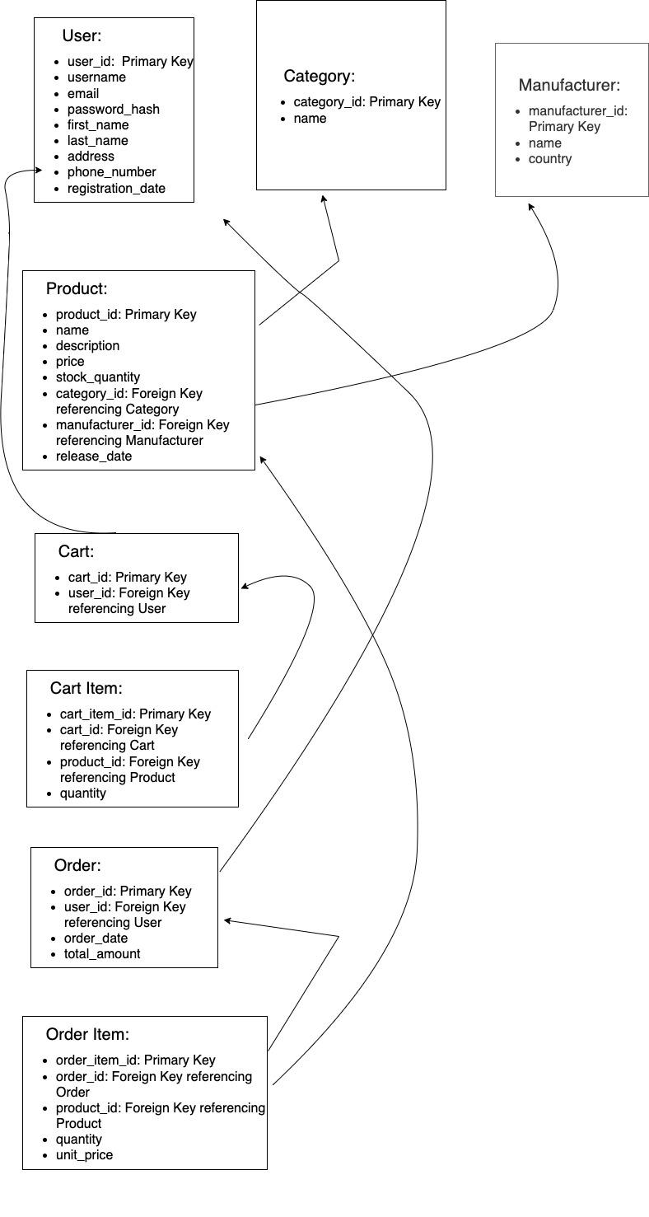

# **Conclusion**

***In this case study, we embarked on a journey to dissect and design a schema for a leading e-commerce platform, taking inspiration from Amazon's functionality. Through the exploration of key features and the subsequent schema design, we gained valuable insights into how data architecture drives the effectiveness of such platforms.***

***We started by choosing Amazon as our reference platform and delved into its top features, understanding how it addresses real-world problems faced by users. We then crafted a schema design that encapsulated the essence of these features, focusing on entities, attributes, and relationships.***